In esports, it is common for tournament organisers to be late to pay players and organisations. Even to the extent where a popular organisation “Windingo” had to shut down after not being paid $500,000 from WESG who is run by Ali Express.

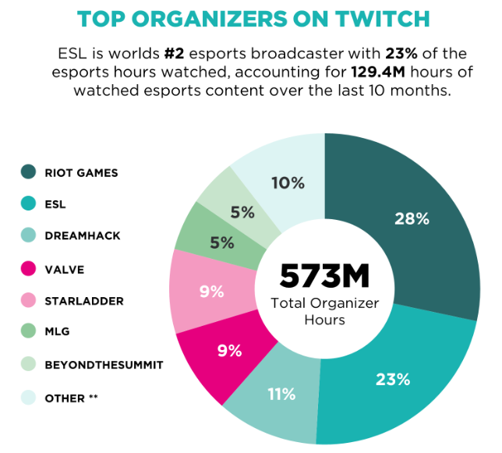It isn’t uncommon for organisers such as WESG, Starladder and ESL, the second biggest organiser for Esports, to do this.

Although it happens more often with players and organisations, it also happens with casters and hosts. This year however, has been different as many people have thought the tournament organisers were “taking the piss” – Vince Hill (Caster).

NewZoo Esports - 2016